

**MASENO UNIVERSITY**

**SCHOOL OF COMPUTING AND INFORMATICS**

**DEPARTMENT OF INFORMATION TECHNOLOGY**

# MASENO E-HEALTH EMERGENCY SYSTEM

**CIT 312: INDIVIDUAL PROJECT**

**PROJECT PROPOSAL SUBMITTED TO THE SCHOOL OF COMPUTING AND INFORMATICS IN PARTIAL FULFILLMENT OF THE REQUIREMENTS FOR THE DEGREE OF BACHELOR OF SCIENCE IN INFORMATION TECHNOLOGY**

**MASENO UNIVERSITY**

**P.O. BOX PRIVATE BAG**

**MASENO, KENYA**

**JUNE, 2022**

# **DECLARATION**

I the undersigned do hereby declare that this project proposal is my own original work and where there’s work or contributions of other individuals, it has been duly acknowledged and relevant citations given. To the best of my knowledge, no material herein has been previously presented to any other academic institution for examination, award of degree or any other award(s).

---------------------------------------------------- ---------------------------------------

**KATUMO BENSON MAKAU Date**

**Admission No. CIT/00046/019**

**Supervisor**

I hereby certify that this project proposal/report has been presented for examination with my approval as the university appointed supervisor.

Supervisor’s Name: **GEORGE OMUONO**

Signature: ______________________________________

Date: __________________________________________

# DEDICATION

I dedicate this proposal first and foremost to Almighty God who has been there since the beginning to this far. Special dedication also to my supportive parents/guardians and friends who have shown total support and compassion towards my achievements. Again, I want to dedicate this proposal to my supervisor Mr. George Omuono and his fellow lecturers for their progressive impact of knowledge.

# ACKNOWLEDGMENT

This Maseno E-Health Emergency System would not have been possible without the support and help of many people. First and foremost I would like to thank the entire Information Technology department for providing valuable guidance for my degree program since the start to this far. Additionally, I would like to thank my project supervisor Mr. George Omuono for dedicating his time to meet, and provide guidance all through this project implementation. Finally, I would like to thank my colleagues for their great contributions towards this project proposal.

# ABSTRACT

Maseno University is an institute of Higher Education that awards academic degrees and other programs in various academic disciplines. Therefore, the internal structure of the university should be well established to produce efficient and effective persons to the society. The university constitutes full-time and part-time students admitted for different programs adding to almost over fifteen thousand students. Presently, when requesting for an ambulance, students have no choice but to contact the driver of the university ambulance. This brings a challenge since the student has to manually give the driver directions to their point of pickup. The driver is incapable of determining the seriousness of the emergency since he/she may lack the medical skills. The driver has to question the student of how they are feeling and based on their own skills, assess the situation. Because of the above challenges and the large number of student population, the health emergency response in Maseno University brings forth problematic scenarios within the institution.

Therefore, to solve these issues, I propose to develop an online emergency reporting and response system for Maseno University. This will encompass emergency reporting, emergency moderation, location tracking and emergency response. By using this proposed system, students will be able to report an emergency and track the response. The university management can track emergencies, moderate and respond to them with the help of the system. The response team on the other side can get the precise location of the student to help in emergency response. The system will also have a chat plugin which will help the students to be in constant communication with the moderators or the drivers at any given point in time. This system will use the System Development Life Cycle framework for development thus making the context of development flexible, adaptable and simple. Finally, the system will include emergency reporting, emergency moderation and emergency response.

# TABLE OF CONTENTS

**MASENO E-HEALTH EMERGENCY SYSTEM 1**

DECLARATION i

DEDICATION ii

ACKNOWLEDGEMENT iii

ABSTRACT iv

TABLE OF CONTENTS v

LIST OF TABLES vii

LIST OF FIGURES viii

CHAPTER ONE: INTRODUCTION 10

1.1 Background Information 10

1.2 Problem Statement 11

1.3 Study Objectives 11

1.3.1 Overall Research Objective 11

1.3.2 Specific Research Objectives 11

1.4 Research Questions 11

1.5 Significance 11

1.6 Limitations 12

1.7 Assumptions 12

CHAPTER TWO: LITERATURE REVIEW 13

2.1 Introduction 13

2.2 Emergency Response 13

2.3 Importance of Emergency Response 14

2.4 Emergency Strategies and Management in Kenya 14

2.6 Emergency Strategies and Management in Kenyan Universities 15

2.6.1 Kisii University 15

2.6.2 Technical University of Kenya 16

2.6.3 Jomo Kenyatta University of Agriculture and Technology 16

CHAPTER THREE: RESEARCH METHODOLOGY 17

3.1 Introduction 17

3.2 Research Design 17

3.3 Population of the Study 17

3.4 Sampling 18

3.4.1 Sample Size 18

3.5 System Development Methodology 18

3.6 System Requirements and Environment 19

3.7 Prototype Design 19

3.7.1 Requirements Gathering and Analysis 19

3.7.2 Prototype Design and Modelling Tools 20

**3.7.2.1 User Requirements Modelling** 20

**3.7.2.1.1 Use Case Modelling** 20

**3.7.2.1.2 Entity Relationship Diagram** 23

**3.7.2.2 Proposed Prototype User Interface Design** 24

3.7.3 Proposed Prototype Development 27

3.8 System Testing and Validation 28

3.9 Ethical Issues 29

REFERENCES 30

APPENDIX A: Call Center Staff Sample Questionnaire 31

APPENDIX B: Paramedics Questionnaire 32

APPENDIX C: Student Interview Questions 33

APPENDIX D: Paramedics Interview Questions 33

APPENDIX E: Call Center Staff Interview Questions 33

APPENDIX F: Literature Review Questionnaire 34

GANTT CHART 35

# LIST OF TABLES

Table 1 Use Case Diagram Breakdown 21

Table 2 Send Emergency Request 22

Table 3 Receive Emergency Request 22

Table 4 Receive Emergency Request 22

# LIST OF FIGURES

Figure 1 Use Case Diagram 21

Figure 2 Entity Relationship Diagram 23

Figure 3 Student Login Page 25

Figure 4 Student Dashboard 25

Figure 5 Student Dashboard after requesting for help 26

Figure 6 Admin Login Page 26

Figure 7 Admin Dashboard 27

Figure 8 Location Tracking of a user 27

# CHAPTER ONE: INTRODUCTION

## 1.1 Background Information

Mitigating the consequences of emergencies is a major challenge in many areas of the world given the limited resources allocated for emergency response. For Maseno University, the major incident is diseases. Due to the lack of an integrated emergency response system, many incidents in Maseno University escalate to such an extent that students end up admitted in hospitals or even lose their lives. Poor coordination of incidents, lack of standard operational procedures, and emergency response operation plans have all been shown to expose victims to increase morbidity and mortality (Wachira, 2013). According to Jeanine Cooper, who was once the head of the UN office for coordination of humanitarian affairs (OCHA-Kenya), Kenya is “ill-prepared” to respond to emergency scenarios. This comes after a series of earth tremors that left every Kenyans in the capital in panic. It was a situation that left Kenyans questioning the country’s ability to respond to emergencies. According to Rono-Bett (Rono-Bett, 2018) Kenya lacks standard operating procedures for multiple types of disasters/emergencies. In addition, emergency response activities have been poorly coordinated, due to lack of standard operational procedures and disaster emergency operation plans. This remains to be a challenge that has led to duplication of efforts and wasteful use of resources. In absence of coordinated plan and action, preparedness and mitigation have not always been attained. In addition, collection of data is not uniformly adequate, which leads to poor planning of emergency response. Similarly, this inadequacy has also resulted in lack of effective monitoring in emergency response situations. Poor coordination of emergency response does not end at the national level, it is the same case experienced in different institutions within the country. Most health emergencies in Maseno University are never respondent to and thus they usually escalate leading to students being admitted in hospitals or losing their lives. Therefore, there is need to develop a system that collects, centralizes data, coordinates emergency response activities and reduces response time for emergency situations for Maseno University. This would save student lives as well as increase recovery from the emergencies. The system should also reduce dependence on human effort, therefore increasing accuracy and making affected students be reached on time.

## 1.2 Problem Statement

The traditional way of responding to health emergencies in Maseno University is slow, inaccurate and unreliable. The procedure itself is dependent on the skills of a human being to assess the situation and gather relevant information from students such as their geolocation. The university lacks a way to track the success or failure of health emergency requests.

## 1.3 Study Objectives

### 1.3.1 Overall Research Objective

* To develop a web-based emergency reporting and response system for Maseno University.

### 1.3.2 Specific Research Objectives

1. To identify challenges of the existing emergency response system in Maseno University.
2. To design an emergency response prototype for Maseno University.
3. To develop the designed emergency response prototype.
4. To test the developed prototype.

## 1.4 Research Questions

1. What are the challenges of the traditional emergency response system in Maseno University?
2. What is the appropriate and suitable design for this system?
3. What implementation approach will be appropriate for this system?
4. What system testing and validation techniques will be suitable for this system?

## 1.5 Significance

The automation of emergency reporting and response in Maseno University will ensure faster emergency reporting, moderation and response. It will ensure students don’t lose their lives and they don’t suffer the consequence of a slow and unreliable emergency response. It will also help track the success or failure of emergency response and help better the system for the benefit of the students.

## 1.6 Limitations

1. Network downtime may hinder the whole emergency reporting and response process.
2. Hosting service outage would render the entire system unavailable.

## 1.7 Assumptions

1. Users have access to fast internet.
2. Users have devices that have GPRS, GPS or have an accurate IP address.
3. Users provide accurate information while reporting emergencies.
4. We assume that the entire process of developing this system will be cost-effective.

# CHAPTER TWO: LITERATURE REVIEW

## 2.1 Introduction

This chapter reviews literature on emergencies, emergency response and emergency response systems in Kenyan Universities. The emergency strategies, successes, failures and challenges in both the nation and the universities within it. The chapter is organized as follows: emergency response, Importance of Emergency Response, Emergency Strategies and Management in Kenya and Emergency response in Kenyan Universities: Kisii University, Technical University of Kenya and Jomo Kenyatta University of Agriculture and Technology.

## 2.2 Emergency Response

There are various definitions of the term emergency. According to Oxford Dictionary (Dictionary, 1989), an emergency is a sudden, unexpected and dangerous situation that requires immediate intervention. On the other hand, Business Dictionary (Gibson, 2009) defines an emergency as a sudden, unexpected and impending situation that can cause loss of life, injury, damage of property and interferes with normal activities thus requiring immediate attention and remedial action**.** From the definitions above, an emergency can therefore be defined as a sudden, unexpected, impending and dangerous situation that causes injury, loss of life and damage to property therefore requiring immediate action that will provide remedy. Emergency response, which is a process of gathering information and resources about the specific emergency case and acting immediately after the incident happens within the shortest time possible is a fundamental and a basic ingredient necessary to lessen the possible impact of the emergency on human life and property. It should be carried out in a systematic manner, since the first actions taken are very critical in determining whether the impact of the emergency will be manageable. An emergency response system is a multi-disciplinary concept that includes not only information technology, but also social communication networks of response agents, and organizational designs (Shen, 2004). According to the National Institute of Environmental Health sciences of the United States , scenarios that can be considered as emergencies include; Shooting, bomb threats, toxic chemical/radioactive/biological spills, criminal activities and terrorist attacks, fire, flooding, accidents and medical emergencies, explosions, earthquakes, hurricanes and civil unrest. The scenarios above require a fast-quick response due to the following facts:

1. A terrorist attack is a scenario that requires immediate response, because many lives are in danger and thus there is need to save them and make sure they are alive and safe.
2. Road accidents require fast response as there is the need to save the lives of those involved in the accident through giving them fast aid and then taking them to the hospital for emergency medical treatment.
3. Fire outbreaks needs immediate response as lives and variable properties are in danger of death and destruction respectively thus the need of saving them from destruction.
4. Toxic chemical and radioactive spills require immediate attendance when they occur to prevent death of people caused by consuming the chemicals in case of contamination.
5. Health related emergencies require quick attention as they may lead to loss of lives if not attended to on time.

In order for these emergencies to be dealt with, the first step should be relevant personnel responding quickly to the emergency. Emergencies therefore require quick emergency response to prevent further harm to people or damage to properties already affected therefore reducing severity and mortality. Quick response also guarantees better chances of recovery from the emergency.

## 2.3 Importance of Emergency Response

Emergency response leads to saving of lives that would be lost if quick action was not taken. Furthermore, property that would otherwise be damaged if not recovered in time is saved.

## 2.4 Emergency Strategies and Management in Kenya

The existing emergency response system in Kenya involves calling a dispatch center for a specified Emergency Response Care provider, where about four or more call recipients are present to receive and respond to calls concerning an emergency. The recipients try to extract information from the affected persons regarding the emergency, the location of the emergency and the persons affected while recording the information. They try to calm down the person calling before extracting information. Once a location has been identified the recipient dispatches the nearest ambulance using GPS that is present in ambulance. As the ambulance gets on its way to the site, the recipient tries to inform the caller on first aid or other steps that can be taken before the ambulance arrives. The call centers can record around sixty or more calls at a time. The limitations of the current emergency response system are that the time taken to extract the information may be prolonged depending how fast the caller is calmed down (Broccoli, 2015). It is also difficult to respond to simultaneous multiple emergencies. The process of manually tracing the location of an ambulance which is nearest for dispatch may be slow and inaccurate. Human induced disasters include accidents, fires, civil unrest and conflicts, terrorism and industrial accidents. One of the challenges Kenya faces while dealing with emergency response is the lack of a reliable central dispatch system therefore people opt for private means such as cars, taxis and trucks which are not well equipped to handle the emergency properly before arriving at the hospital. Without a coordinated response system there is the potential of unnecessary increase in morbidity and mortality. Kenya does not have an organized national emergency or trauma care system according Benjamin Wachira, (Wachira, 2013). Another challenge is the lack of accessible direct and toll-free lines for use in case of emergencies. According to Benjamin Wachira, (Wachira, 2013), challenges facing emergency services in Kenya include lack of integrated emergency services that the public can easily access to receive timely emergency care, lack of adequate resources to handle emergencies and poor coordination of major incident management activities lack of specific training for emergency services personnel as well as the general public, unavailable emergency phone lines as well as transport related barriers due to lack of emergency care after business hours. These are the same challenges that Maseno University currently experiences.

## 2.6 Emergency Strategies and Management in Kenyan Universities

Most Kenyan Universities have not fully integrated emergency response systems into their institutional systems. The few which have emergency response systems are unreliable and inefficient. Therefore many students end up seeking private healthcare services. The following are some of the Kenya Universities that I reviewed:

### 2.6.1 Kisii University

Kisii University is one of the recent universities which won their charter in less than nine years ago. Being one of the youngest universities, it’s still under development and thus most of the services offered by the institution are not very reliable. The university has a hospital inside the school although many students prefer private hospitals to the university hospital. Kisii University doesn’t have an ambulance which it’s an implication that in the event that a student falls sick, they have to find their own means to reach the hospital. Kisii university students ranked the quality of services offered by the university hospital very poor. These outcomes lays to the table the fact that, the institution lacks enough resources to better their services or poor management of the resources. Kisii University lacks an emergency response system that the students can easily access to receive timely emergency care, adequate resources to handle emergencies, specific training for emergency services personnel, and general public emergency phone lines. The University also doesn’t have toll free lines through which the students can report any emergencies.

### 2.6.2 Technical University of Kenya

Technical University of Kenya provides students with a phone number through which the student can call or send a text message requesting for ambulance. The student is however requested to vividly describe his/ her situation and their geo-location. This kind of system has however worked for some students although the majority of the students claim that the process is extremely grueling. The students have to inform the driver of how they are feeling and also manually direct the driver to their location of pickup. The driver has to pick the student without further understanding of the seriousness of the disease the student is suffering from and take them to the hospital. Most students end up desperate and consider seeking medical attention from hospitals outside the institution. Technical University of Kenya lacks an emergency response system that the students can easily access to receive timely emergency care, adequate resources to handle emergencies, specific training for emergency services personnel, and general public emergency phone lines and thus proving the need to have an emergency reporting and response system in the institution.

### 2.6.3 Jomo Kenyatta University of Agriculture and Technology

Jomo Kenyatta University of Agriculture and Technology is one of the oldest universities having been established as a university in 1994. Jomo Kenyatta University of Agriculture and Technology has not exhausted the technology as its emergency services are still traditional. The university provides students with a phone number through which the students reach the university hospital and request for an ambulance to pick them when they get ill. The students however are asked to manually give directions of their residence and also explain to the paramedics how they are feeling so as to be given first aid instructions. Some students have however used this method and got helped, although, the larger percentage has proven their dissatisfaction with the existing system. Jomo Kenyatta University of Agriculture and Technology lacks an emergency response system that the students can easily access to receive timely emergency care, adequate resources to handle emergencies, specific training for emergency services personnel, and general public emergency phone lines and thus proving the need to rely on technology to handle emergency reporting and response in the institution.

# CHAPTER THREE: RESEARCH METHODOLOGY

## 3.1 Introduction

Research refers the systematic investigation into and study of materials and sources in order to establish facts and reach new conclusions. Research methodology incorporates principles practices and procedures required to carry out research. This chapter describes the steps, procedures, techniques and tools used to realize the research objectives and is organized as follows Research Design, Population of the Study, Sampling and Sample Size, Proposed System Development Methodology, Systems Analysis, Design and Development, **Systems Testing and Validation**, Results Analysis & Presentation, Ethical Issues.

## 3.2 Research Design

The research design for the study was exploratory research design. Since the research explored and attempted to test a prototype and establish its performance, the steps that were undertaken were as follows:

1. Defining the project scope.
2. User requirements gathering and analysis.
3. Prototype functional requirements identification and specification.
4. Prototyping the web-based emergency response system.
5. Testing of the prototype.

## 3.3 Population of the Study

The population of this study involved the emergency response staff that includes the ambulance drivers and paramedics, the call center staff and students involved in an emergency scenario where they required emergency response services. The total population consisted of thirty people; five drivers, five paramedics, five call center staff and fifteen students who have been involved in an emergency scenario within Maseno University. This population helped us gather the information required during an emergency in order to respond efficiently to an emergency with sufficient information to respond to an incident without need for further information to accurately respond to the emergency.

## 3.4 Sampling

The study used purposive Sampling technique. Purposeful sampling is widely used in qualitative research for the identification and selection of information-rich cases related to the phenomenon of interest (Alinkas, 2015). This study identified individuals that interact directly with the current emergency response system to identify the requirements, the procedures, the challenges and the workflow in an emergency scenario from call to action in any scenario.

### 3.4.1 Sample Size

Mugenda and Mugenda (Mugenda, 2003) explains that a population is a group of individuals or objects that have the same form of characteristics. They are the “totality of cases that conform to certain specifications, which defines the elements that are included or excluded in the target group”. This study focuses on the emergency response system in Maseno University and the entities that interact with it. The sampling size entailed 30 individuals distributed among the individuals that interact with the current emergency response system in Maseno University. As mentioned above in the population of study, the population of this study involved the emergency response staff that includes the ambulance drivers and paramedics, the call center staff and few isolated cases of students involved in an emergency scenario where they required emergency response services within the university. Therefore five drivers, five paramedics, five call center staff and fifteen students who have had been involved in emergency scenarios constituted the sample size. This ensured the quality of information rather than the quantity of information.

## 3.5 System Development Methodology

Agile methodology was deployed for the development of Maseno E-Health Emergency System. Agile was used because of its ability to minimize risks during the development process such as bugs, cost overruns and changing requirements in the event that a new functionality was being added. Some agile development methods include scrum and extreme programming. The Agile methodology contains six phases: concept, inception, iteration, release, maintenance and retirement. This type of methodology will ensure the following in our system development;

* There will be rapid, continuous development and delivery of useful software.
* Regular adaptation to changing circumstances.
* The communication keeps the stakeholders involved in the entire system development.

## 3.6 System Requirements and Environment

System requirements are all the necessary requirements that devices and computers must have for the proper functioning of a system efficiently without any problems incurred.

**Minimum system requirements for students**

1. Mobile phone or tablet running Android or iOS.
2. Internet connectivity, Wi-Fi, 3G or 4G connectivity.
3. Have GPRS or GPS sensors on the device.
4. Browser application such as Google Chrome, Mozilla Firefox, Safari browser or Opera Mini that can execute and has JavaScript enabled.

**Minimum system requirements for Moderators**

1. PC running Windows, Linux or MAC Operating Systems.
2. Internet connectivity, Wi-Fi or Ethernet connection
3. Browser application such as Google Chrome, Mozilla Firefox, Safari browser or Opera Mini that can execute and has JavaScript enabled.

**Minimum system requirements for Rescue Team**

1. Mobile phone or tablet running Android or iOS or a PC.
2. Internet connectivity, Wi-Fi, 3G or 4G connectivity
3. Have GPRS or GPS sensors on the device
4. Browser application such as Google Chrome, Mozilla Firefox, Safari browser or Opera Mini that can execute and has JavaScript enabled.

## 3.7 Prototype Design

The study used several tools to model the system. UML is a collection of diagrams and models that are used in representing the analysis, design and implementation of systems in an object-oriented approach. The UML models provide an effective way to represent the design of proposed system prototype include; use case diagrams, activity diagrams and Entity Relational Diagrams.

### 3.7.1 Requirements Gathering and Analysis

Requirements were gathered before and after the system was developed. Gathering of the requirements before prototype development enabled the developer to understand the user specifications that needed to be in the system, for it to have an impact on the target audience. After the development of the prototype, the data collected enabled the developer to gauge the user experience of the system and make changes where possible. The requirements gathering and analysis was accomplished using primary and secondary data.

**Primary data sources**

**Structured Online Questionnaires**

This enabled the researcher to get answers to specific questions which helped in prototype design. The researcher used this method both before and after prototype development. This helped in understanding user requirements (before development) and gauging user experience (after development). This method was used because it is quick and easy to use, besides getting specific results needed. Furthermore, the questionnaires were online because internet access is widely available and guarantees quick response.

**Open Interviews**

This enabled me get more information concerning the system. Since the interviews were not closed, the respondent was at liberty to give more details concerning the system, which helped have a deeper understanding of user requirements and user experience.

**Secondary Data Sources**

Collection of this meant that we were to collect information on existing systems. The internet was a powerful tool here, since we used it to explore tools, frameworks and architectures closely related to our prototype, as well as the challenges on existing systems that proved the fact that the use of technology in the prototype would overcome the existing challenges. Data analysis involves breaking the data into smaller pieces, which can be easily understood and aid in decision making. In our case we used tables to analyze quantitative data.

### 3.7.2 Prototype Design and Modelling Tools

#### **3.7.2.1 User Requirements Modelling**

##### **3.7.2.1.1 Use Case Modelling**

The use case (figure 1) has three types of actors; student, moderator and response team. The student actor is the one who primarily benefits from the execution of the use case, that is, the user who receives the emergency response. A moderator is the one who directly interfaces with the system to initiate or trigger the system event. On the other hand, the response team is one which responds to the request from the use case. This will require the use of Use Case Diagrams to show the tasks performed by the system actors. The figure below represents the interactions.

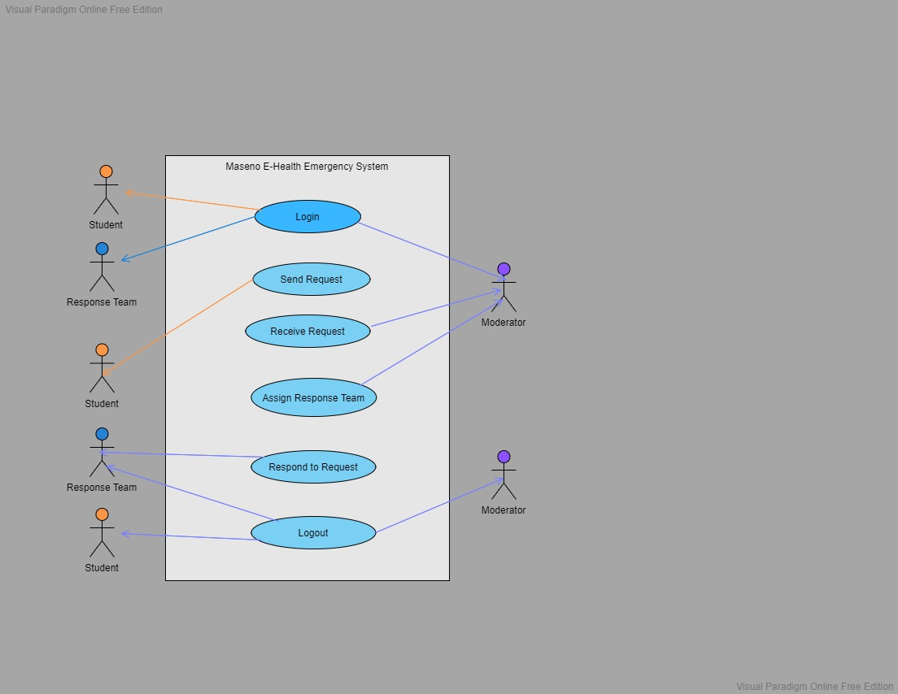

Figure 1 Use Case Diagram

To make the understanding of the use case simpler, we will use a table.

Table 1 Use Case Diagram Breakdown

|  |  |
| --- | --- |
| **Actor** | **Use Case** |
| Student | Send Emergency Request |
| Moderator | Receive Emergency Request |
| Response Team | Respond to Emergency Request |

The user use case will deal with sending emergency request, a task initiated by the student. The student will need to access the web application and fill in credentials to login. If authenticated, the user will then be required fill in a small form and click on a button to send for emergency request on the webpage. The emergency request will submit relevant information to the moderator.

The first use case (send emergency request) is described in a little more detail in the table 2. The second use case is described in table 3 and the third use case described in table 4.

Table 2 Send Emergency Request

|  |  |
| --- | --- |
| **ID** | **CASE 1** |
| TITLE | Send Emergency Request |
| DESCRIPTION | Fill a small form and click a button on the webpage that automatically requests for emergency response. |
| ACTORS | Student |
| PRE-CONDITIONS | The student is logged in |
| POST-CONDITIONS | None |
| SUCCESS SCENARIO | The student successfully submits the emergency response request and his/her geo-location is submitted to the moderator. |

Table 3 Receive Emergency Request

|  |  |
| --- | --- |
| **ID** | **CASE 2** |
| TITLE | Receive emergency request |
| DESCRIPTION | Moderator receives the emergency request and location of student, assigns and dispatches a response team. |
| ACTORS | Moderator |
| PRE-CONDITIONS | Dispatch interface is up and running |
| POST-CONDITIONS | Nearest ambulance to the system user is located |
| SUCCESS SCENARIO | Moderator sends a dispatch team. |

Table 4 Receive Emergency Request

|  |  |
| --- | --- |
| **ID** | **CASE 3** |
| TITLE | Receive Emergency Request |
| DESCRIPTION | Response team logs in to the system and checks requests assigned to them then clicks a button to agree to attend to that task. |
| ACTORS | Response Team |
| PRE-CONDITIONS | Ambulance interface is on |
| POST-CONDITIONS | Nearest ambulance to the system user is located |
| SUCCESS SCENARIO | Request correspondent sends a dispatch team |

##### **3.7.2.1.2 Entity Relationship Diagram**

Figure 2 shows an entity relationship diagram that depicts the entities in the developed prototype and specifies the relationships between instances of the entities. The proposed system uses one database with ninetables. The tables represent the entities and they are:

1. student_details
2. admin_details
3. request_status
4. rescue_team
5. rescue_team_members
6. rescue_team_tasks
7. role_details
8. success_list
9. failed_list

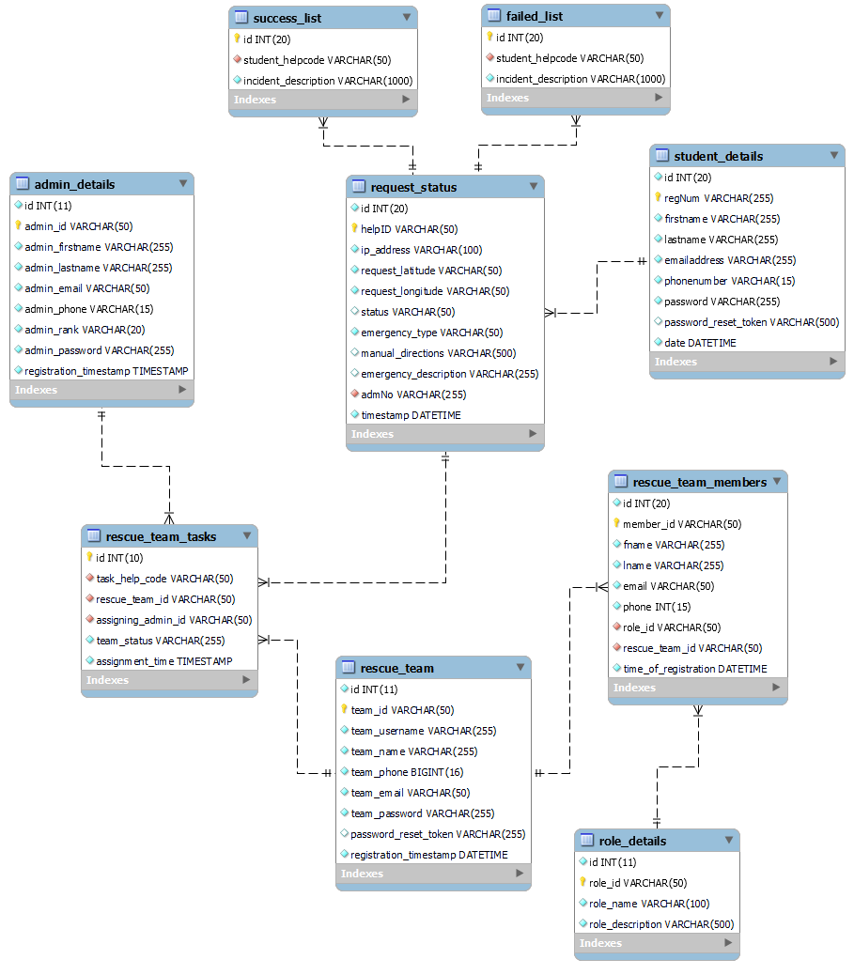

Figure 2 Entity Relationship Diagram

The following relationships exist for the entities:

**student_details to request_status**: the relationship is a one to one relationship where the student’s request is assigned a unique help code to track each specific student emergency rescue request. The *admNo* column of the *request_status* entity acts as a foreign key for student_details (regNum) and allows the identification of the student who requested for rescue as well as more information concerning the student.

**rescue_team_tasks to admin_details**: the relationship is a one to one relationship where a single request task is assigned a single admin (moderator) to assign and moderate the specific task. The primary key of the *admin_details (admin_id)* entity is used as a foreign key in *rescue_team_tasks (assigning_admin_id*) and allows the identification of the moderator who assigned the task to a certain rescue team as well as more information concerning the about the moderator (admin).

**rescue_team_tasks to rescue_team**: the relationship is a one to one relationship where a single request team is assigned a single task. The primary key of the rescue_team (team_id) entity is used as a foreign key in *rescue_team_tasks (rescue_team_id)* and allows the identification of the specific rescue team that was assigned a certain rescue task as well as more information concerning the about rescue team.

**rescue_team_members to role_details**: the relationship is a one to many relationship where a single request team can have many team members. The primary key of the *role_details (role_id)* entity is used as a foreign key in *rescue_team_members**(role_id)* and allows the identification of the specific rescue team member and their role in a specific rescue team.

**student_request_rescue to success_list:** the relationship is a one to one relationship. It depicts more information about the student rescue request when describing a successful response to an emergency.

**student_request_rescue to fail_list:** the relationship is a one to one relationship. It depicts more information about the student rescue request when describing a failed response to an emergency.

#### **3.7.2.2 Proposed Prototype User Interface Design**

The user interface design of this prototype was created using wireframe sketcher with the aim of showcasing the proposed user interface.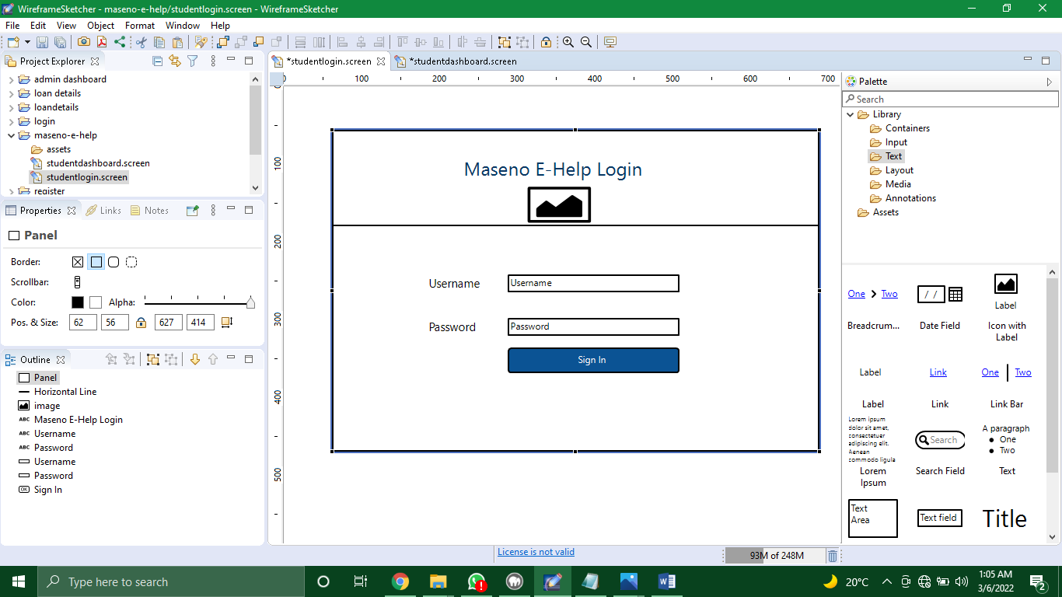

Figure 3 Student Login Page

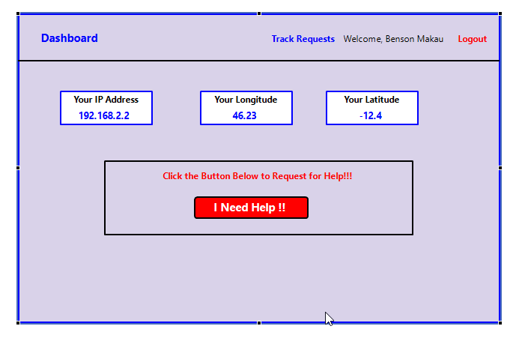

Figure 4 Student Dashboard

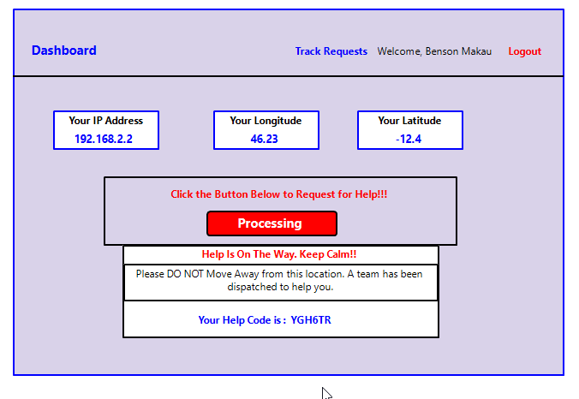

Figure 5 Student Dashboard after requesting for help

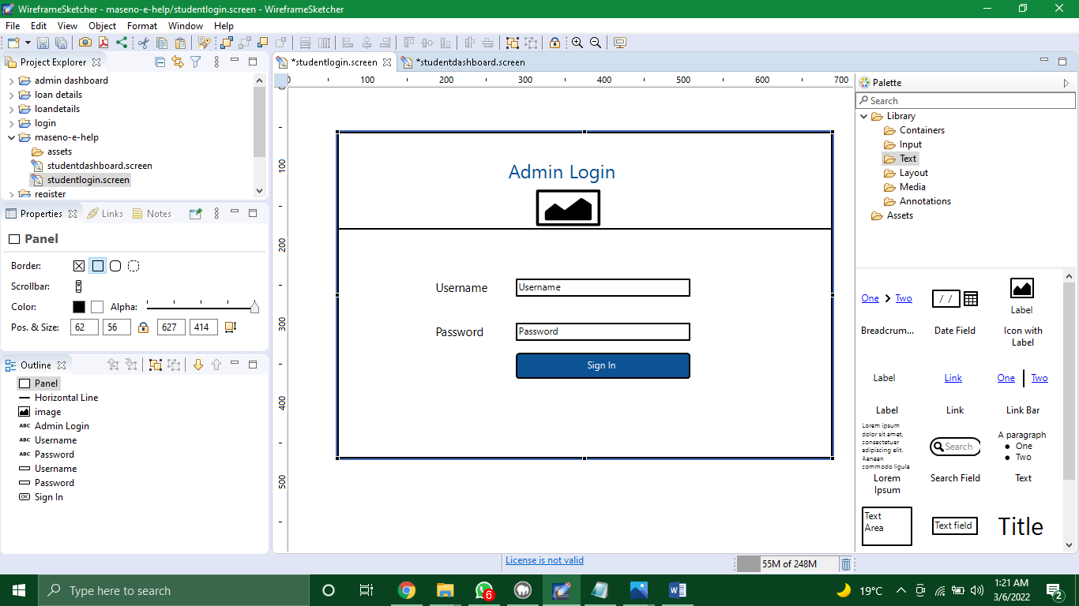

Figure 6 Admin Login Page

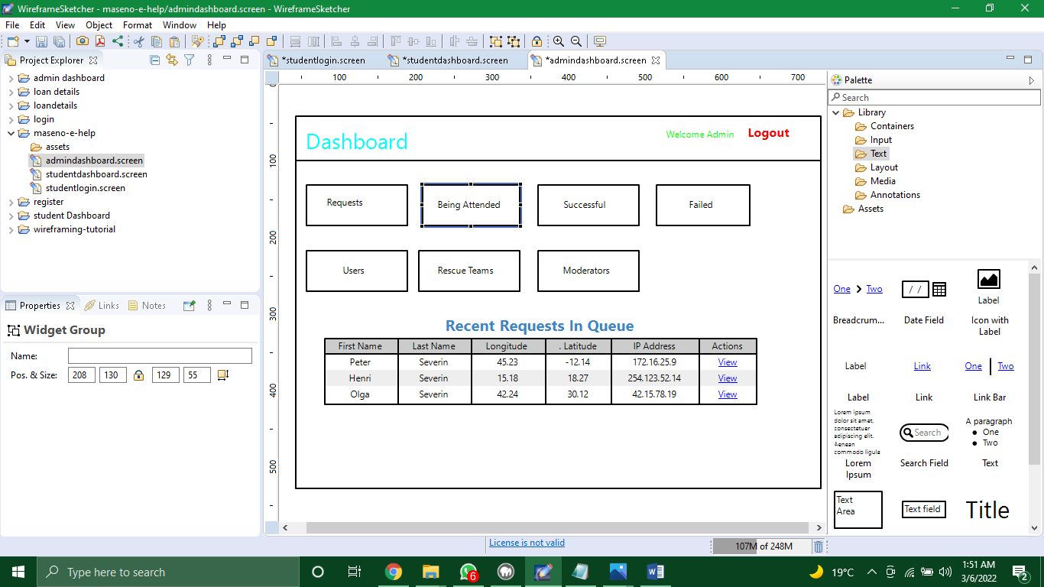

Figure 7 Moderator Dashboard

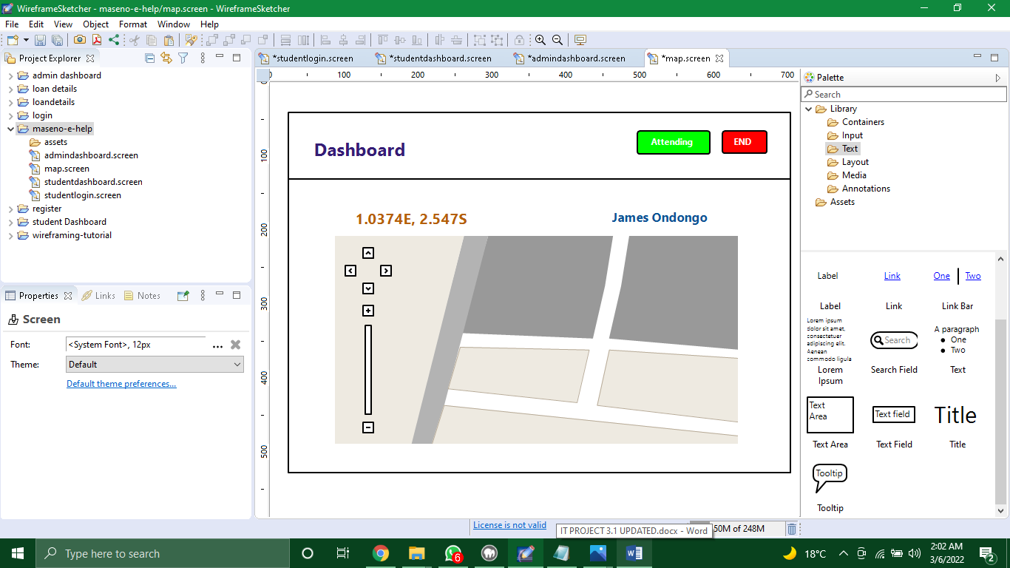

Figure 8 Location Tracking of a Student

### 3.7.3 Proposed Prototype Development

The proposed prototype shall be developed using the following technologies and platforms:

**Wireframe Sketcher**

Wireframe Sketcher is a wire framing tool that helps designers and developers quickly create wireframes, mockups and prototypes for desktop, web and mobile applications. It’s a desktop app. This enabled us get a sketchy look (mockup) of our prototype before we did the actual coding. Thus, we were able to design our user interfaces, before coding.

**Bootstrap Framework**

Bootstrap is a free front-end framework for faster and easier web development. Bootstrap includes HTML and CSS based design templates for typography, forms, buttons, tables, navigation, modals, image carousels and many other, as well as optional JavaScript plugins. Bootstrap also gives you the ability to easily create responsive designs. We will use bootstrap for creating the user interfaces.

**PHP**

PHP is a widely-used open source general-purpose server-side scripting language that is especially suited for web development and can be embedded into HTML pages. While bootstrap designs the UI, PHP processes the logic (backend development) of the webpage. We used PHP as a server side scripting language for our prototype.

**MySQL**

This is an open source relational database management system. It compiles on multiple platforms and uses standard SQL statements. It is the most popular database system used with PHP, therefore, using PHP, we can connect to and manipulate our database. For this system, we embraced MySQL as our database management system.

**API**

An API is a set of programming code that enables data transmission between one software product and another. It also contains the terms of this data exchange. For this project, we employed different Map API to help in fetching user location and displaying map direction to the source of request.

## 3.8 System Testing and Validation

System testing and validation will involve the following steps;

1. Unit Testing- Each component will be independently tested to check its performance. There will be a checklist of all the components and the requirements expected from each component. The evaluation will be to check:
2. Whether the required functionality is available and working as expected.
3. The security of the component against any potential threats
4. Whether the components meets the acceptable response time limits
5. The Integration Testing - The components will be assembled to verify how good the components are inter-networked. At this stage, the performance of the whole system will be tested, its efficiency, effectiveness, response time, data transfer mechanisms, security and any possible bugs in the system. The system will be tested under extreme test data to determine if it is reliable.
6. System Testing- An environment resembling that of a normal working system will be set up. At this step, we tested the performance of the system, the extreme load it can handle, stress testing, and its scalability.
7. Testing User Acceptance- Its goal is to evaluate users’ satisfaction with the system. This includes asking for feedback about the prototype from a few picked users, this includes the students, moderators, and rescue team.

## 3.9 Ethical Issues

Wiles (Wiles, 2008) argues that ethical considerations such as confidentiality and anonymity are very important issues in research. Cappelleri, (Cappelleri, 1995) cited that researchers should acknowledge sources of secondary information such as textbooks and research materials. Since my study has used secondary data such as papers and journals, in accordance with research respect and copyright, I will acknowledge my sources of information. I will also maintain confidentiality and anonymity of the respondents. All the test data provided by different respondents will be handled discretely. All the participators of this project will be supervised to ensure they are professional and ethical.

# CHAPTER 4 : RESULTS AND CONCLUSION

As per the specific objectives, results on the project proposal were able to be identified and collected. They are explained and elaborated as follows in various sections.

**Identification of Challenges of the Existing Emergency Response System in Maseno University.**

The current traditional emergency response system utilizes phone calls to receive requests and respond to emergencies. The challenges of this system include: bureaucracy in the procedure to responding to these emergencies. The process is slow since it requires escalation in the event a case cannot be handled. The process requires the knowledge of the specific emergency response team contact number and thus can be time consuming.

**Design an emergency response prototype for Maseno University**

Based on the needs of the system, designs of the database, data flow, use case, and user interface were created and evaluated. The designs gave a pathway to the actual development of the prototype.

**Develop the designed emergency response prototype.**

The figures that follow are the actual screens that were developed. The steps of interaction are outlined for each figure.

# REFERENCES

Alinkas, L. H. S. G. C. W. J. D. N. a. H., 2015. Purposeful sampling for qualitative data collection and analysis in mixed method implementation research. *Administration and policy in mental health and mental health services research*, pp. 533-544.

Broccoli, M. C. E. S. A. W. B. a. W. L., 2015. Perceptions of emergency care in Kenyan communities lacking access to formalised emergency medical systems. *a qualitative study. BMJ open*.

Cappelleri, J. a. T. W., 1995. Ethical and scientific features of cutoff-based designs of clinical trials.. *A simulation study. Medical Decision Making*, pp. 387-394.

Dictionary, O., 1989. Oxford english dictionary.. *Simpson, Ja & Weiner*, p. 3.

Gibson, K., 2009. BusinessDictionary. com. *Reference Reviews.*.

Mugenda, O. a. M. A., 2003. Research Methods: Sample size determination. *African Centre For Technology Studies.*.

Rono-Bett, K. C., 2018. A political economy analysis of decision-making on natural disaster preparedness in Kenya.. *Jàmbá: Journal of Disaster Risk Studies,*, pp. 1-8.

Shen, S. a. S. M., 2004. Managing coordination in emergency response systems with information technologies.. *AMCIS 2004 Proceedings*, p. 252.

Wachira, B. a. S. W., 2013. Major incidents in Kenya: the case for emergency services development and training.. *Prehospital and disaster medicine*, pp. 170-173.

Wiles, R. C. G. H. S. a. C. V., 2008. The management of confidentiality and anonymity in social research.. *International journal of social research methodology*, pp. 417-428.

# APPENDIX A: Call Center Staff Sample Questionnaire

1. What kind of emergency response organization are you?

* Private
* Government

1. What is the average wait time for a user making a call before the call is re-queued again?

* 5-10 Minutes
* 10-30 Minutes
* 30- 60 Minutes
* More than 60 Minutes

1. How fast does it take to dispatch an ambulance?

* 5-10 Minutes
* 10-30 Minutes
* 30- 60 Minutes
* More than 60 Minutes

1. What’s type of data you extract from a caller in need of emergency response?

* Name of caller
* Location
* Type of emergency

1. How long does a user have to wait, on average, incase all response teams are occupied?
   * 5-10 Minutes
   * 10-30 Minutes
   * 30- 60 Minutes
   * More than 60 Minutes

# APPENDIX B: Paramedics Questionnaire

1. Check the type of data needed to respond to an emergency

* Name of caller
* Location
* Type of emergency

1. How much time does it take to respond to an emergency after receiving a request from the dispatch center?

* 5-10 Minutes
* 10-30 Minutes
* 30- 60 Minutes
* More than 60 Minutes

1. Do you use geo-location or any form of location identification device to locate the location of the emergency?

* Yes
* No

1. In your opinion what success rates do you hit when responding to emergencies in a day? (How many out of 10 emergencies do you effectively respond to and on time?)

__________ out of 10

# APPENDIX C: Student Interview Questions

1. What are your views on the current emergency response system in Maseno University in accordance with response times?
2. What do you think could be incorporated into the current systems to make them effective?

# APPENDIX D: Paramedics Interview Questions

1. How often do you handle emergencies daily or weekly?
2. How well explained are the instructions from the dispatch center?
3. What is the maximum radius you can operate in a day?
4. What technologies do you use while responding to emergencies?

# APPENDIX E: Call Center Staff Interview Questions

1. How many emergencies can you send dispatch to at a go?
2. What are the challenges you face at the call center that result to delay in responding to an emergency?
3. What is the escalation process for emergencies that cannot be directly handled once a call has been received?
4. What happens when there are no available response teams or are all currently occupied at an instance?

# APPENDIX F: Literature Review Questionnaire

1. What is your name ________________________________
2. As you a student? ____ If yes, at which university? ______________________________
3. What is your email address? ________________________________
4. Have you ever fallen sick before while at the university? _______________
5. How did you request for help? ……………………………………………………………………………………………………………………………………………………………………………………………...
6. Does the university have an ambulance? _________
7. If your answer above is yes, describe the process to request an ambulance within the university……………………………………………………………………………………………………………………………………………………………………………………………………………………………………………………………………………………

………………………………………………………………………………………………

1. Do you feel that the process is convenient? _______ Why? ………………………………………………………………………………………………………………………………………………………………………………………………

………………………………………………………………………………………………

1. Would you prefer the university hospital to other hospitals outside the institution? _______ Why? ………………………………………………………………………………………………………………………………………………………………………………………………

………………………………………………………………………………………………

1. On a scale of 1 to 10, how likely would you recommend an online emergency reporting and response system to be implemented at your institution? _________ of 10.

(1 least likely and 10 most likely)

# GANTT CHART

|  |  |  |  |  |  |  |  |  |  |  |
| --- | --- | --- | --- | --- | --- | --- | --- | --- | --- | --- |
| **WEEKS**    **Deliverables** | WEEK 1 | WEEK 2 | WEEK 3 | WEEK 4 | WEEK 5 | WEEK 6 | WEEK  7 | WEEK  8 | WEEK  9 | WEEK  10 |
| Present Gantt Chart |  |  |  |  |  |  |  |  |  |  |
| System Design Implementation |  |  |  |  |  |  |  |  |  |  |
| Student UI functionality Implementation |  |  |  | |  |  |  |  |  |  |
| Moderator UI functionality Implementation |  |  |  |  |  | |  |  |  |  |
| Response Team UI functionality Implementation |  |  |  |  |  |  |  |  |  |  |
| Database Implementation and getting Real Data |  |  |  |  |  |  |  |  |  |  |
| System Testing  & Project Documentation |  |  |  |  |  |  |  |  |  |  |
| Presentation to Supervisor |  |  |  |  |  |  |  |  |  |  |